[logo]

—--------------------------------------- [green banner, white text]----------

We are Rise Up Austin,  
a local grassroots movement.

—----------------------------------[end banner]---------------------------

# Rise Up Austin is a coalition of citizens for bold solutions without divides to build a safe, affordable Austin through active participation and accountable leadership.

We are committed to:

* **Restoring safety and affordability** to revive Austin’s vibrant spirit and unique community.
* **Empowering Austinites** to rise up and shape policies that echo our community’s values.
* **Elevating citizen-statemen** to bring accountable and competent leadership to our local government.

—--------------------------------------- [blue banner, white text]----------

# Protect affordability in Austin. Get involved in the campaign against Prop Q.

—----------------------------------[end banner]---------------------------

## **Prop Q makes Austin less affordable.** The Tax Rate Election on November 4th threatens to increase the city’s property taxes by 20%. It introduces a new baseline tax rate that will impact every Austin resident and business forever.

The most important thing we can do to defeat the tax rate election is educate voters and make sure that they turn out to vote against Prop Q. If you are on social media or belong to a community group, please be sure to raise your concerns often. Many people in Austin are still unaware that Prop Q threatens to raise the city property tax rate 20%, forever.

## Want to help educate voters?

**Download and share this flyer.** [https://drive.google.com/file/d/1uUAaoTnKYzvGzvnodYKpDd6if3w_e0BB/view?usp=drivesdk]

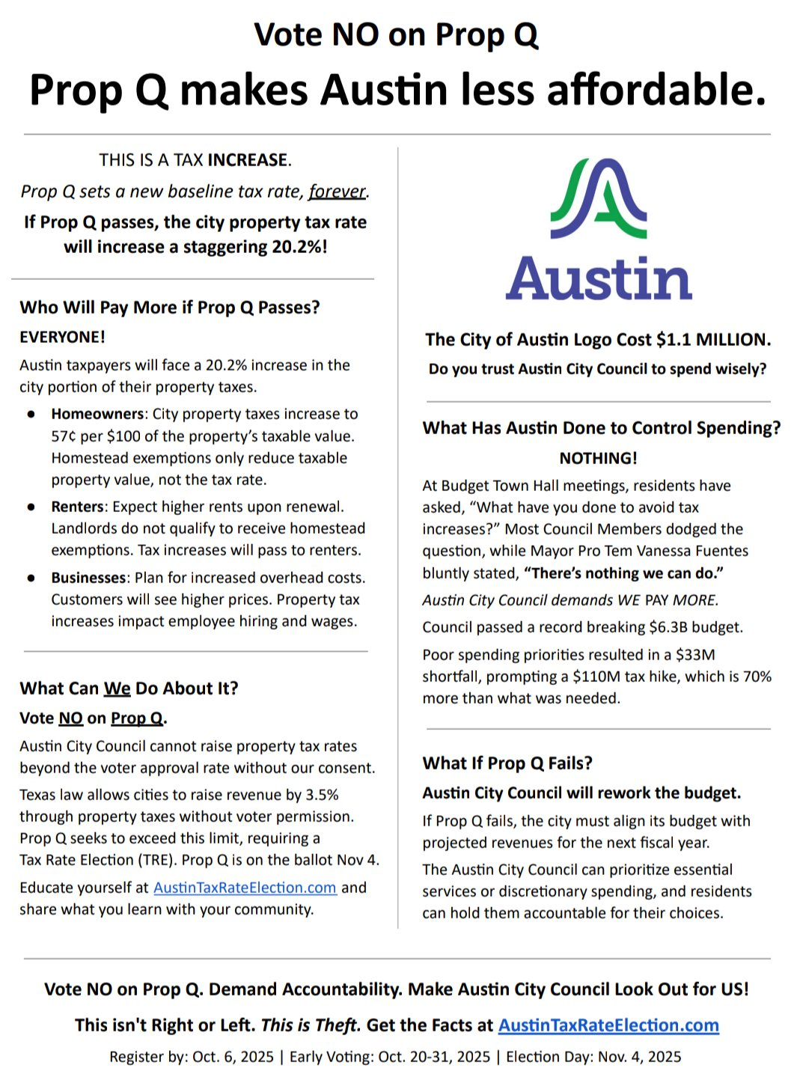

## Want to help canvass or help with other volunteer efforts?

Fill out our Vote No on Prop Q volunteer survey. [https://forms.zohopublic.com/votenoqgm1/form/VoteNoonPropQVolunteerSignUp/formperma/JIZv0x1SHfTPzElBK-pv3ysmHO_pVt_g0F20Y_vHouw]

—----------------------------------[green banner, white text]------------------

# Stay informed [email capture]

—----------------------------------[end banner]----------------------------------